1. Download the "crack-these-please.zip  unzip. You need to make sure this file is unzipped and in your Kali virtual machine.  This should have 50 users with various passwords. Copy this file to the john the ripper folder. Look at your unzipped crack-these-please file using cat, what's it look like?

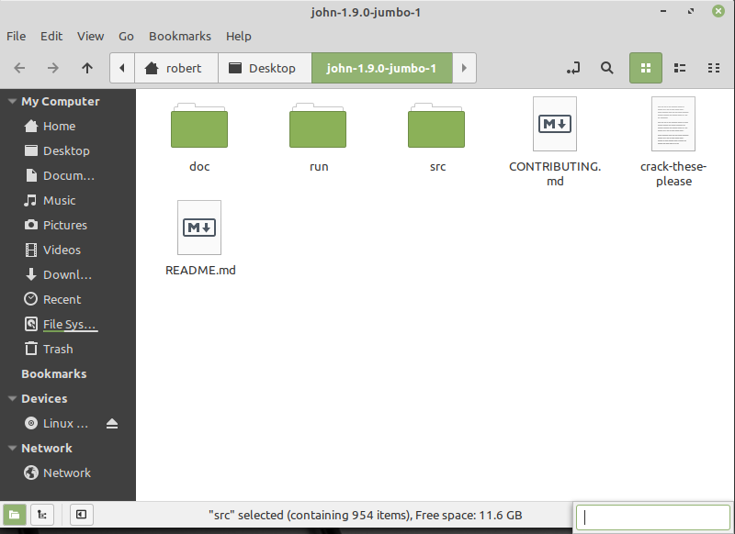(picture 1)

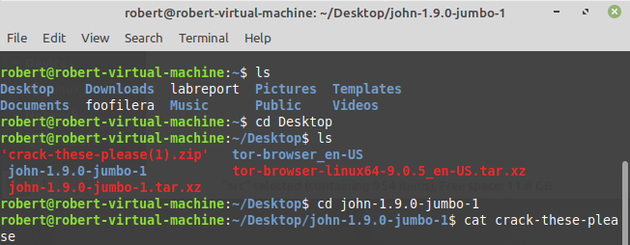

(picture 2)

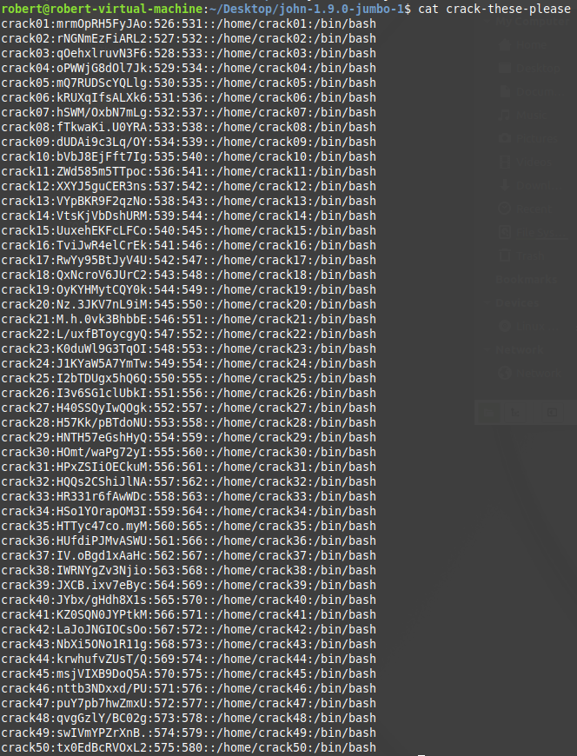

(picture 3)

Check the directory for a file called password.lst. Dump the file's contents to the screen by giving the command: more  password.lst

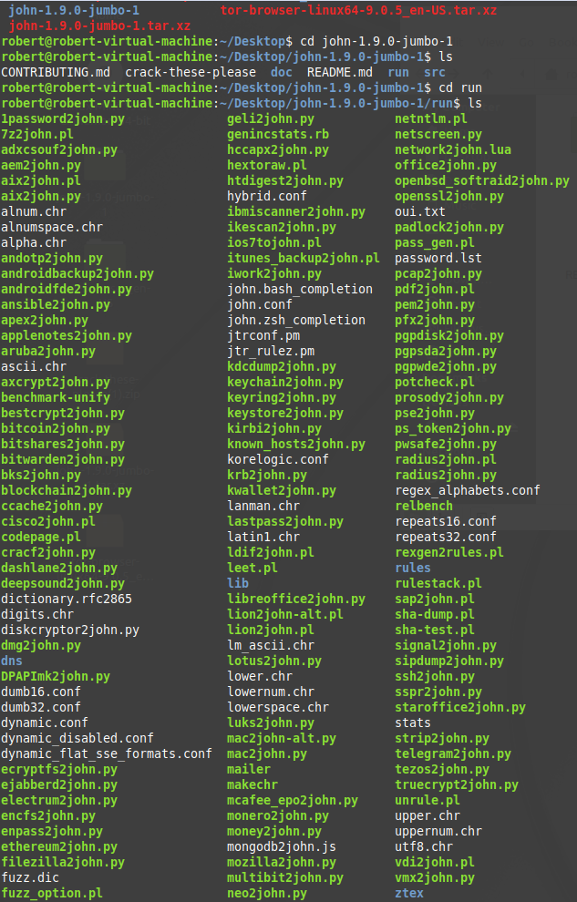(picture 4)

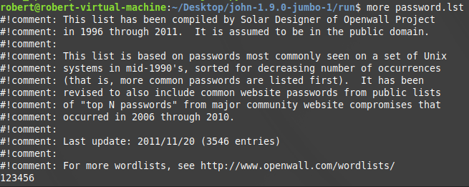(picture 5)

Press the spacebar, or hold it down, to make the display advance to the end of the file. You see that it is a list of potential passwords. There are about 3000 of them.

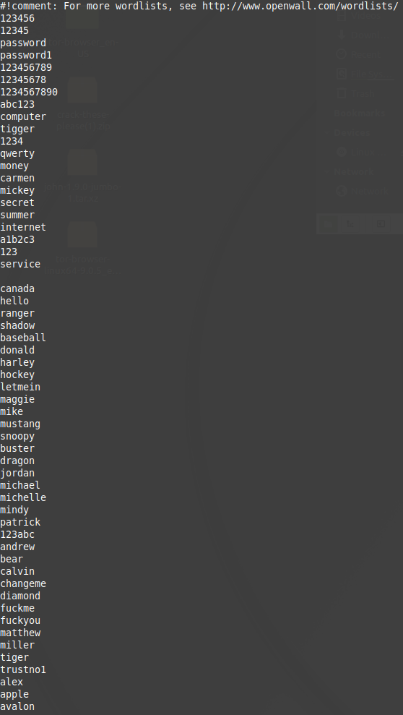(picture 6)

Enter the following command to launch a dictionary attack: john --wordlist crack-these-please

However, we need to install the john package first

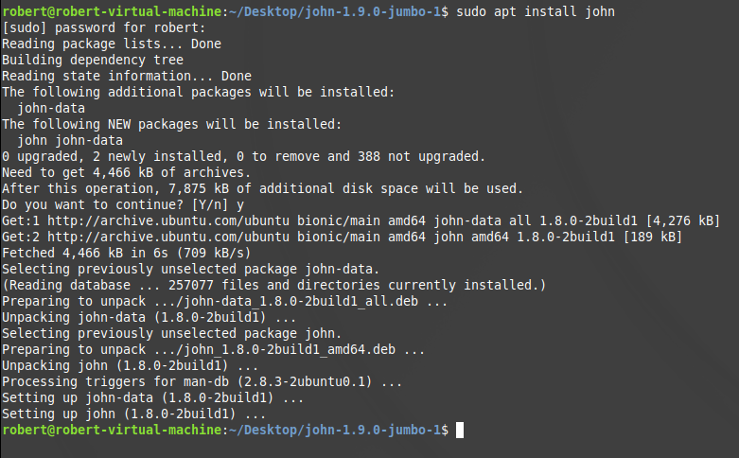(picture 7)

Note: Took me few hours to figured out that the **password.lst** must be in the same directory as **crack-these-please**

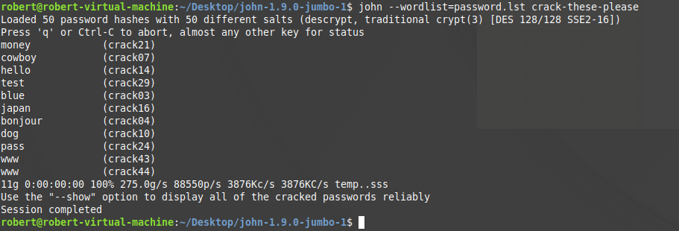

(picture 8)

Take a screenshot showing how many of the 50 passwords it was able to crack, what they are, and the time it took. John has created a list of solved passwords called john.pot.

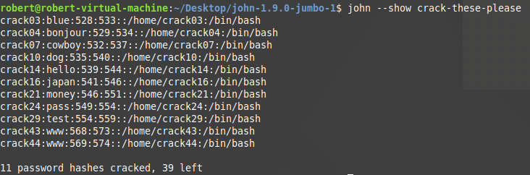(picture 9)

3. In default usage John the Ripper executes dictionary, hybrid, and bruteforce attacks in combination. Launch a combination attack by executing:

john crack-these-please

While john is working, examine the CPU utilization of your computer.

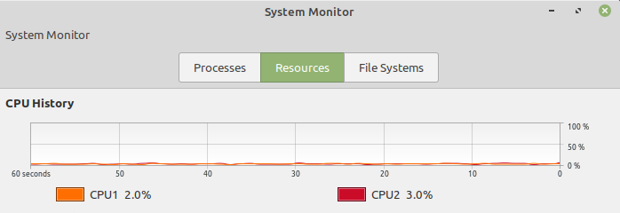

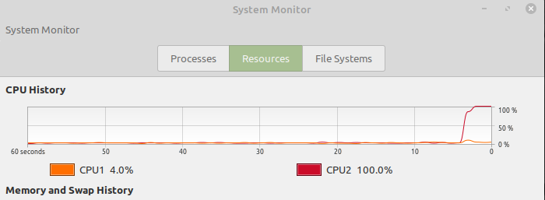(pictures 10)

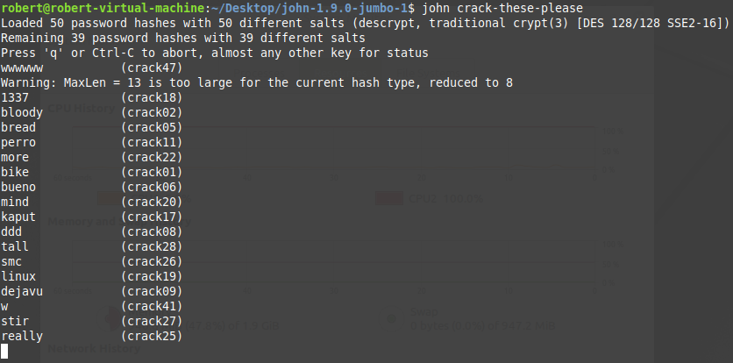(picture 11)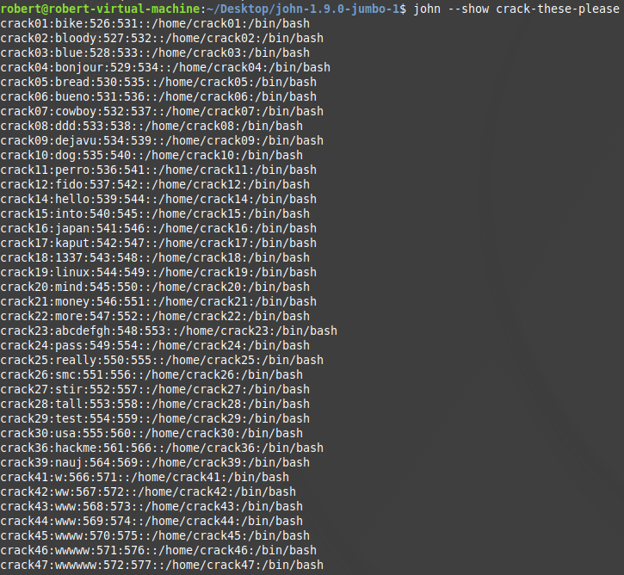(picture 12)

Using the dictionary attack **john --wordlist = password.lst crack-these-please,** the tool cracked 11 passwords out of 39. (Refer to pictures 8 and 9 for more references). Using the default crack command: John crack-these-please, the tool cracked 47 out 50. Refers to (picture 12). John may have cracked the remainder password. However, it was taking awhile.